

وزارة التعليم العالي والبحث العلمي

جامعة نينوى

كلية تكنلوجيا المعلومات

**Advanced Digital**

**Image & Signal**

**Processing**

**Report**

**Applying Digital Image Processing Filters in Photoshop**

**Raheed Fadi & Hanan Salih**

**Used Images**

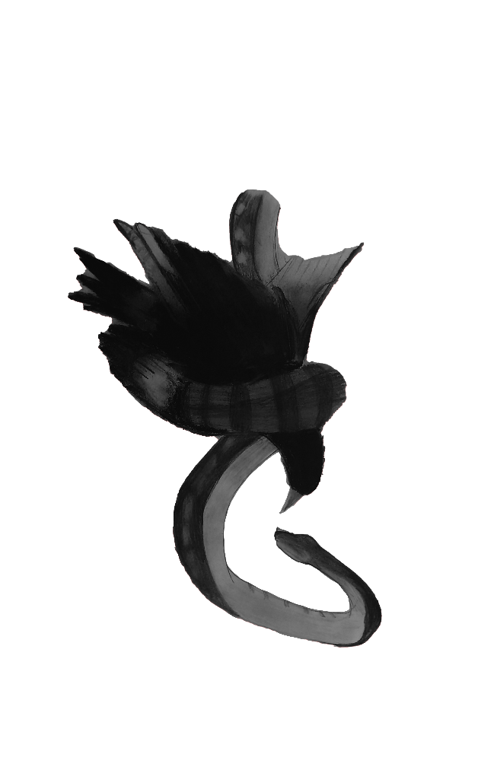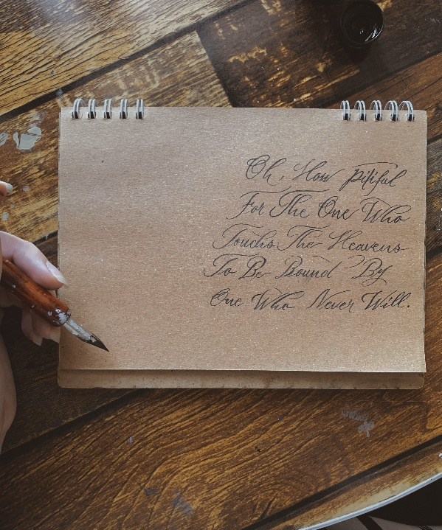

**Work Progress**

**Step 1:**

Insert the images into photoshop:

open photoshop >> drag and drop the images into photoshop

**Step 2:**

Crop the images to the wanted size:

On the left of photoshop window at toolbar select crop tool and adjust the size

**Or**

Press C >> adjust the size

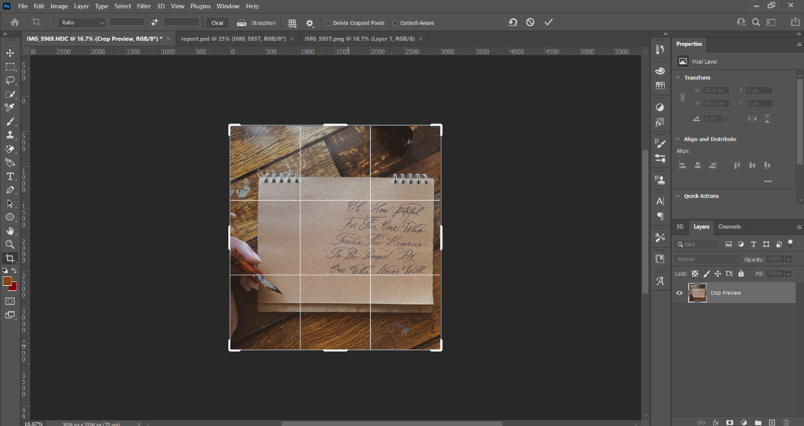

**Step 3:**

Adjust the layers on top of each other to blend them.

**Step 4:**

Apply black and white filter to turn the image colors into gray scale.

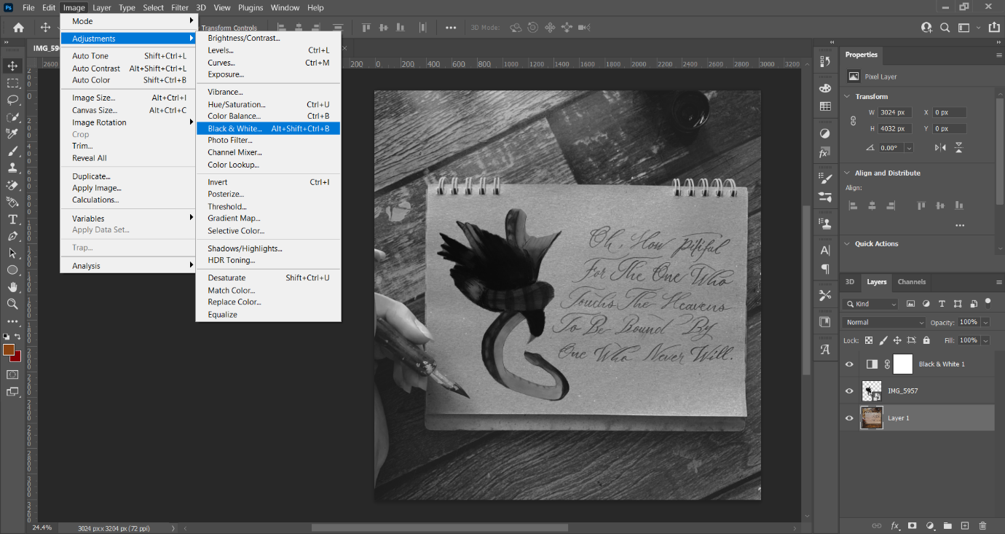Image >> adjustments >> Black & White

**Why Gray Scale instead of RGB?**

1. Reduced Computational Complexity

- RGB images have three color channels (Red, Green, Blue), while gray scale images have only one.

- Processing a grayscale image requires fewer calculations, making algorithms run faster and more efficiently.

2. Noise Reduction

- Color information can introduce noise and unnecessary details.

**Step 5:**

Blending the second layer with the first one by adjusting the opacity and the underlying layer

Right click on the second picture >> blending options

General blending >> set the opacity to 85%

Advanced blending >> set the fill opacity to 90%

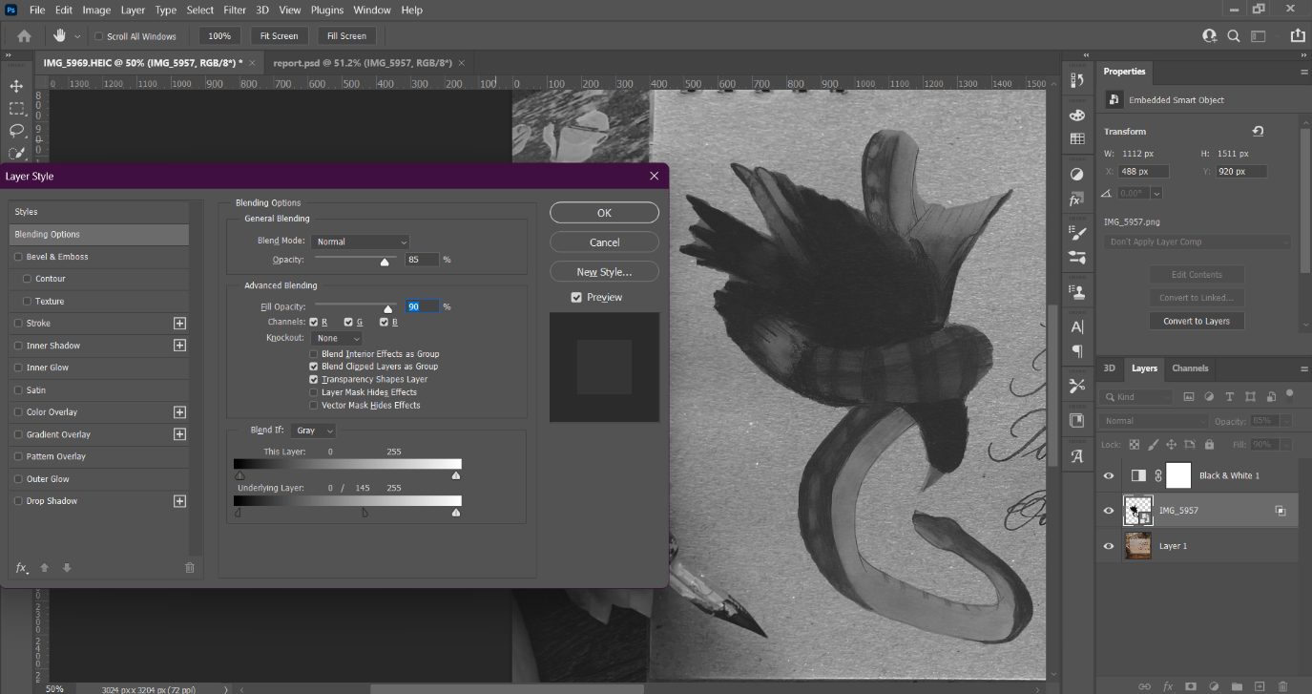Blend if >> set the underlying layer to 0 / 145 255

**How does it work?**In RGBA images, each pixel has four components (R(Red), G(Green),

B(Blue) and A(Alpha)).

The Alpha channel (A) determines how much the pixel blends with the background.

EX:

(255, 0, 0, 255) → Fully opaque red.

(255, 0, 0, 128) → 50% transparent red.

(255, 0, 0, 0) → Fully transparent (invisible).

**Step 6:**

Adjusting the contrast for the first layer using histogram (contrast stretching)

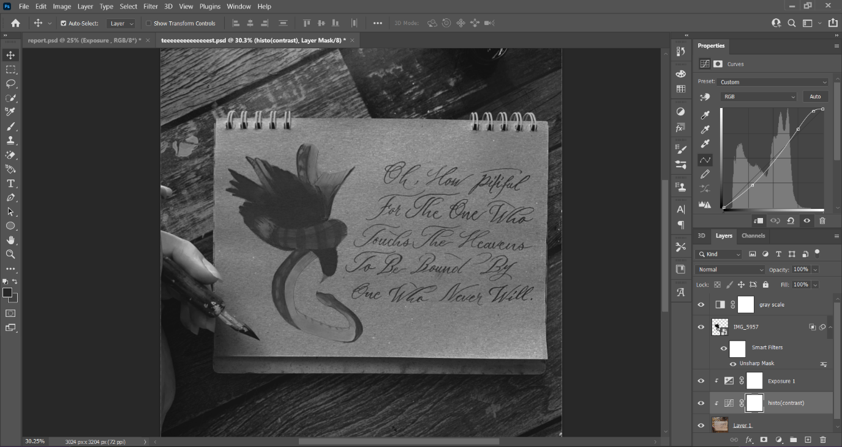Select the layer >> image >> adjustments >> curves >> adjust the curve

**why histogram?**

- Redistributes pixel intensities to achieve a more uniform histogram.

- Works on Grayscale & Color Images

- Gives wider range to modification.

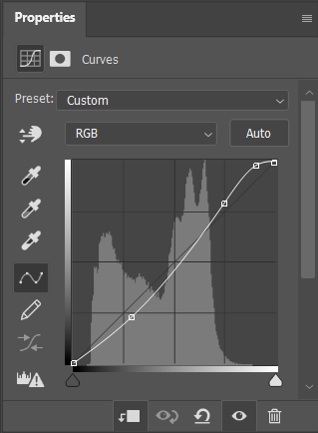

**Step 7:**

Adjusting the exposure for the first layer.

Select the layer >> image >> adjustments >> exposure

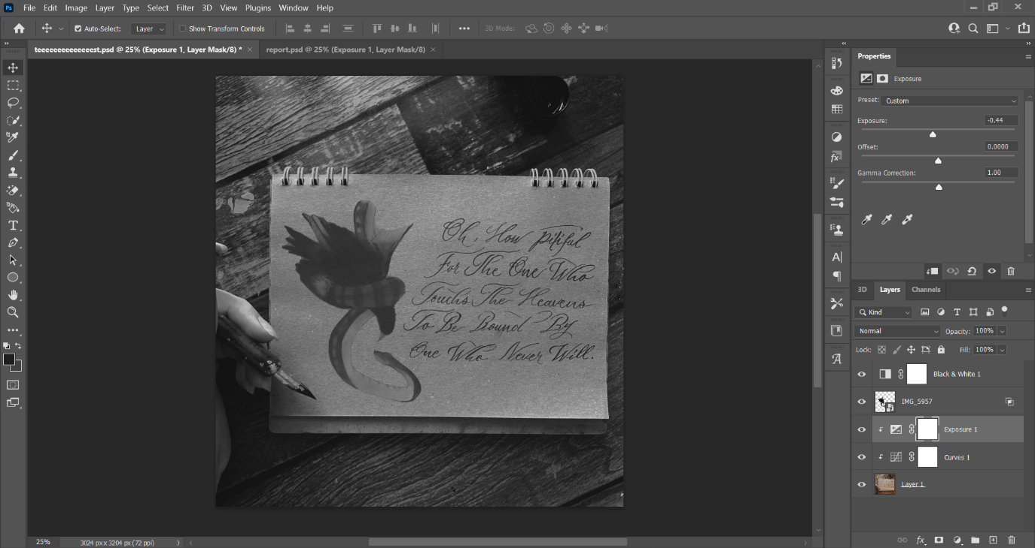set the exposure to -0.44

**What is Exposure and why we use it?**

Exposure in digital image processing refers to the amount of light captured by a camera sensor.

The filter is used for:

- Improving Image Visibility

- Better Contrast and Dynamic Range

**Note: histogram can also adjust the Exposure but in our case we wanted to improve the performance of the histogram and adjusting the contrast to enhance the image quality.**

**step 8:**

Adding more sharpness to the second layer to match the sharpness of the first one and adding more texture to the second one using unsharp filter

select the layer >> filter >> sharpen >> unsharp mask

amount: 50%

radius: 10.0 pixels

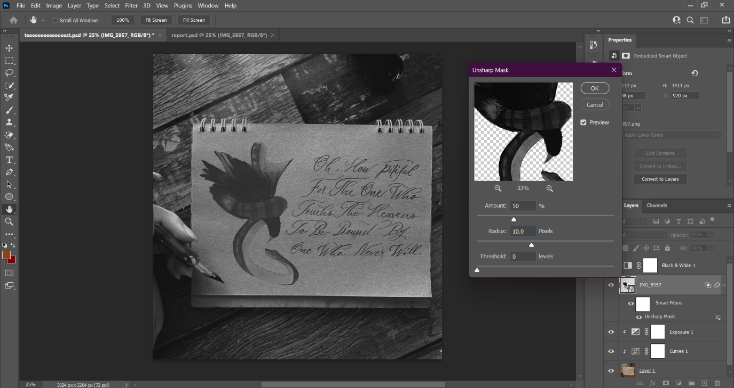

**Why unsharp filter?**

Unsharp: sharpen images by subtracting a blurred or unsharp(smoothed) version of an image from the original image itself.

We used it to add more details to the second image.

**Step 9:**

export the image.

file >> export >> Quick Export as PNG

**Result Image**

